EXERCISE 1:
E-COMMERCE PLATFORM USING SEARCH FUNCTION
import java.util.Arrays;

class Product {
int productId;
String productName;
String category;

Product(int id, String name, String cat) {
this.productId = id;
this.productName = name;
this.category = cat;
}

void display() {
System.out.println(productId + " - " + productName + " (" + category + ")");
}
}
public class Main {
// Linear Search
public static Product linearSearch(Product[] products, int id) {
for (Product p : products) {
if (p.productId == id) {
return p;
}
}
return null;
}

// Binary Search (Assumes sorted array by productId)
public static Product binarySearch(Product[] products, int id) {
int left = 0, right = products.length - 1;
while (left <= right) {
int mid = (left + right) / 2;
if (products[mid].productId == id) return products[mid];
if (products[mid].productId < id) left = mid + 1;
else right = mid - 1;
}
return null;
}

public static void main(String[] args) {
Product[] products = {
new Product(103, "Keyboard", "Electronics"),
new Product(101, "Shoes", "Apparel"),
new Product(104, "Book", "Stationery"),
new Product(102, "Phone", "Electronics")
};

// For Binary Search: sort by productId
Arrays.sort(products, (a, b) -> a.productId - b.productId);

// Test Linear Search
Product found1 = linearSearch(products, 104);
System.out.println("Linear Search:");
if (found1 != null) found1.display(); else System.out.println("Not Found");

// Test Binary Search
Product found2 = binarySearch(products, 102);
System.out.println("\nBinary Search:");
if (found2 != null) found2.display(); else System.out.println("Not Found");
}
}
Using JDoodle compiler

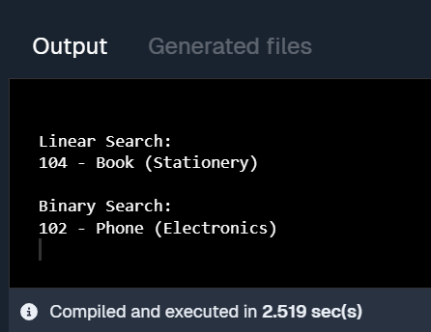

EXERCISE 2:
FINANCIAL FORECASTING

public class Main {
// Recursive method to calculate future value
public static double forecastFutureValue(double initialAmount, double growthRate, int years) {
// Base case: if no more years, return the initial amount
if (years == 0) return initialAmount;

// Recursive step: calculate value for previous year and apply growth
return forecastFutureValue(initialAmount, growthRate, years - 1) * (1 + growthRate);
}

public static void main(String[] args) {
double initialAmount = 1000.0; // starting value in currency
double growthRate = 0.05; // 5% growth per year
int years = 5; // forecast for 5 years
double futureValue = forecastFutureValue(initialAmount, growthRate, years);
System.out.printf("Forecasted value after %d years: %.2f\n", years, futureValue);
}
}
Using JDoodle compiler

